Lab Report: Which Binder is the Best?

Researcher Names:

Hypothesis:

Materials:

Terracotta pot

Hammer

Towel or cloth

Elmer’s glue

Super glue

Epoxy

Rubber cement

B72 adhesive

Observations of terracotta pot before restoration:

Procedure:

1.

2.

3.

Data Table
Binder | Observations

Super glue

Epoxy

Rubber cement

B72 adhesive

Conclusion:

NORTH CAROLINA MUSEUM OF ART: CONSERVATION LABORATORY
EXAMINATION REPORT
Artist: |  | Treatment Number:
Title:
Date:
Size:
Materials:
Examiner:
Examination Date(s):

Construction:

Condition:

NORTH CAROLINA MUSEUM OF ART CONSERVATION LABORATORY
RECOMMENDED TREATMENT
Treatment Number:
Artist:
Title:
Examiner:
Examination Date(s):

Proposed Treatment Plan:

Proposed Treatment—Additional Comments:
NORTH CAROLINA MUSEUM OF ART: CONSERVATION LABORATORY
TREATMENT REPORT
Treatment Number: | 96.4.29
Artist: | Unknown New World, Costa Rican, Guanacaste-Nicoya Zone
Title: | Crocodile Effigy Vessel
Examiner: | William P. Brown
Examination Date(s): | April 1999

Proposed Treatment Plan:
- Sized edges of broken pieces with dilute B-72. Kept sizing to inside 2/3 of edge to avoid staining exterior skin along edges.

- Glued pieces together with B-72 glue.

- Reinforced the glue joints from the interior with B-72 bulked with fumed silica.

- Sized edges of glue joints with Soluvar to serve as a masking for the fills.

- Filled losses along joints with Latex Spackle toned with dry pigment. When the Soluvar was removed ghosting from the fill material came away.

- Inpainted fills with watercolor.

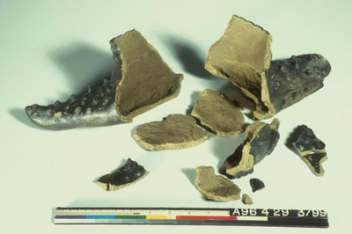
Crocodile Effigy Vessel before conservation

