Art and Source Text Handout

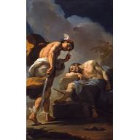
Ubaldo Gandolfi,
Mercury About to Behead Argus, circa 1770–1775
North Carolina Museum of Art

Prometheus and Io
She gave Io into the charge of Argus, an excellent arrangement for Hera’s purpose, since Argus had a hundred eyes. Before such a watchman, who could sleep with some of the eyes and keep on guard with the rest, Zeus seemed helpless … At last, however, he went to his son Hermes, the messenger of the gods, and told him he must find a way to kill Argus. There was no god cleverer than Hermes. As soon as he had sprung to earth from heaven he laid aside everything that marked him as a god and approached Argus like a country fellow, playing very sweetly upon a pipe of reeds. Argus was pleased at the sound and called to the musician to come nearer … He played and then he talked on and on, as drowsily and monotonously as he could; some of the hundred eyes would go to sleep, but some were always awake. At last however, one story was successful … The little story does not seem especially tiresome, as such stories go, but Argus found it so. All of his eyes went to sleep. Hermes killed him at once, of course, but Hera took the eyes and set them in the tail of the peacock.

--Adapted from “Prometheus and Io” in Edith Hamilton’s Mythology

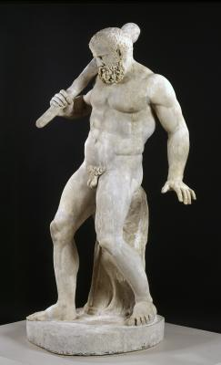
Roman, after Hellenistic original
Herakles, 2nd Century
North Carolina Museum of Art

Hercules and the Nemean Lion
Setting out on such a seemingly impossible labor, Hercules came to a town called Cleonae, where he stayed at the house of a poor workman-for-hire, Molorchus. When his host offered to sacrifice an animal to pray for a safe lion hunt, Hercules asked him to wait 30 days. If the hero returned with the lion's skin, they would sacrifice to Zeus, king of the gods. If Hercules died trying to kill the lion, Molorchus agreed to sacrifice instead to Hercules, as a hero.

When Hercules got to Nemea and began tracking the terrible lion, he soon discovered his arrows were useless against the beast. Hercules picked up his club and went after the lion. Following it to a cave which had two entrances, Hercules blocked one of the doorways, then approached the fierce lion through the other. Grasping the lion in his mighty arms, and ignoring its powerful claws, he held it tightly until he'd choked it to death.

Hercules returned to Cleonae, carrying the dead lion, and found Molorchus on the 30th day after he'd left for the hunt. Instead of sacrificing to Hercules as a dead man, Molorchus and Hercules were able to sacrifice together, to Zeus.
Story Source: Perseus Digital Library, http://www.perseus.tufts.edu/Herakles/lion.html

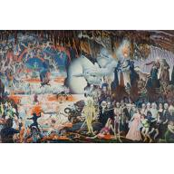
McKendree Robbins Long
Apocalyptic Scene with Philosophers and Historical Figures, about 1959
North Carolina Museum of Art

The Divine Comedy
From Canto III
And I: “What is it, master, that oppresses
these souls, compelling them to wail so loud?”
He answered: “I shall tell you in few words.
Those who are here can place no hope in death,
And their blind life is so abject that they
are envious of every other fate.
The world will no fame of theirs endure;
Both justice and compassion must disdain them;
Let us not talk of them, but look and pass.”

From Canto V
There dreadful Minos stands, gnashing his teeth:
examining the sins of those who enter,
he judges and assigns as his tail twines.
I mean that when the spirit born to evil
appears before him, it confesses all;
and he, the connoisseur of sin, can tell
The depth in Hell appropriate to it;
as many times as Minos wraps his tail
around himself, that marks the sinner’s level.

From Canto XII
Now with our faithful escort, we advanced
along the bloodred, boiling ditch’s banks,
beside the piercing cries of those who boiled.
I saw some who were sunk up to their brows,
and that huge Centaur said: “These are the tyrants
who plunged their hands in blood and plundering.
Here they lament their ruthless crimes; here are
both Alexander and the fierce Dionysius,
who brought such years of grief to Sicily.

Alighieri, Dante. “Inferno.” The Divine Comedy. Trans. Allen Mandelbaum. New York: Everyman’s Library, 1995.

